**P2V Migration using VMware Converter Server**

**V2V MIGRATION USING VMWARE VCENTER CONVERTER**

***Procedure for Initial replication***:

**Objective**: To migrate virtual machine from one datacenter to another datacenter

**Prerequisites**: Optimized wan path from source to destination

New IP for the server at Destination

DNS Registration during the final synchronization

Initial replication of server

**Procedure**: Log on to the Vcenter server

Open VMware vcenter converter

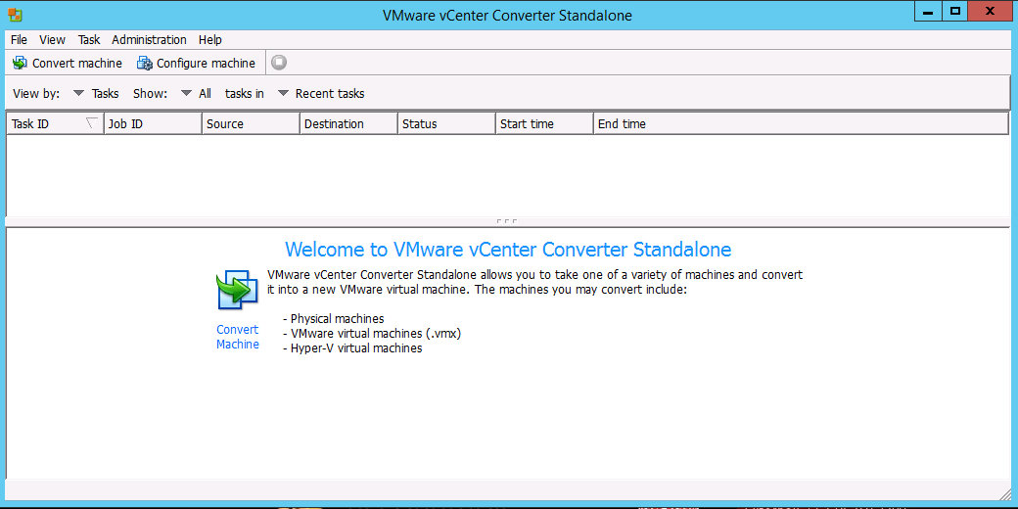

Click on convert machine

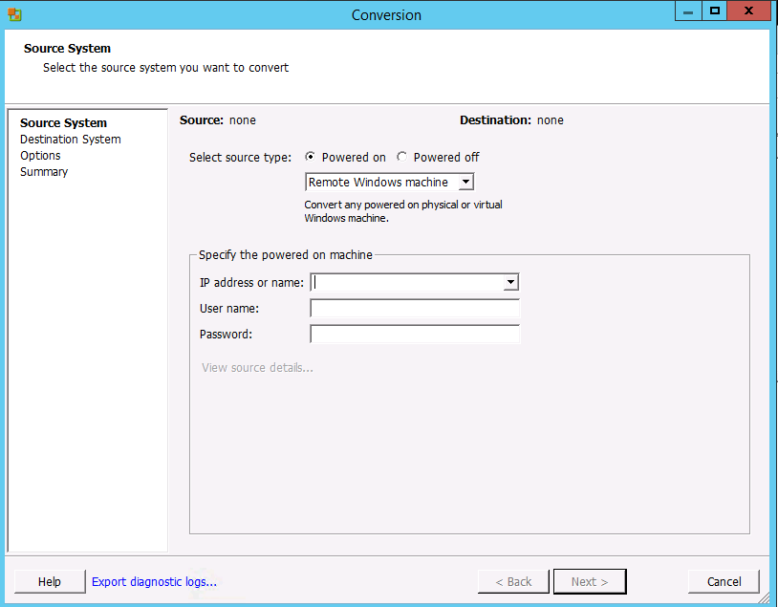

Select the powered-on option

Select the Remote windows machine

Enter the Ip address or hostname of the server

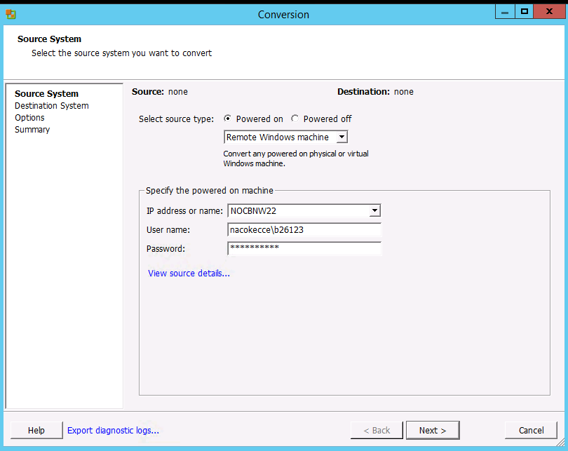

Enter the credentials and click Next

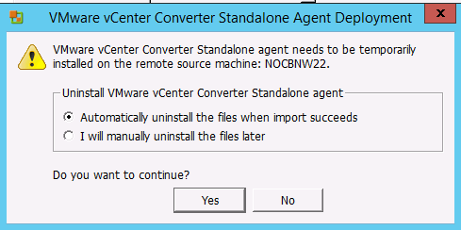

Click yes agent will be installed on the source machine

Deploying Agent

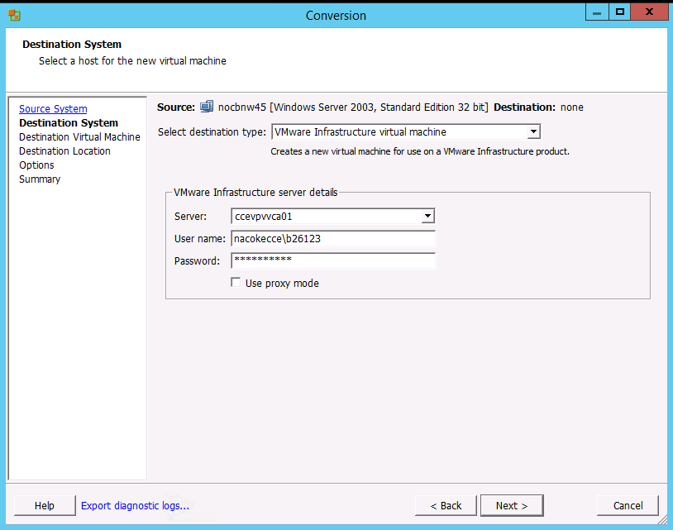

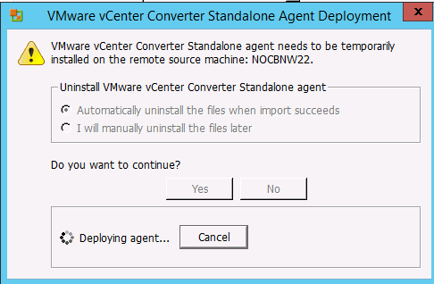

Enter the credentials of vcenter

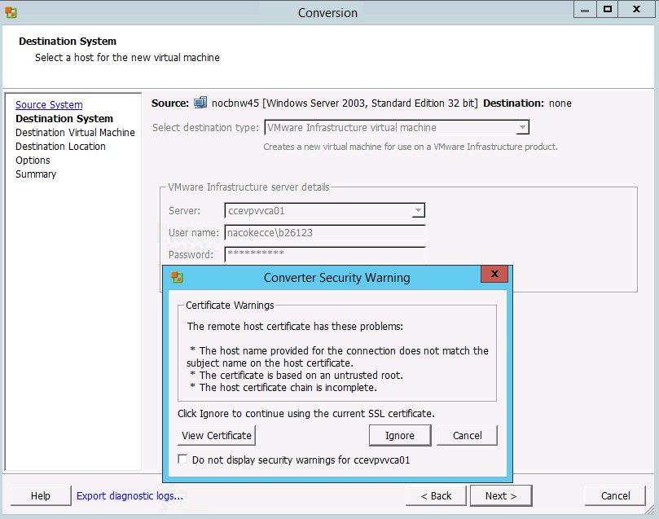

Click on Ignore

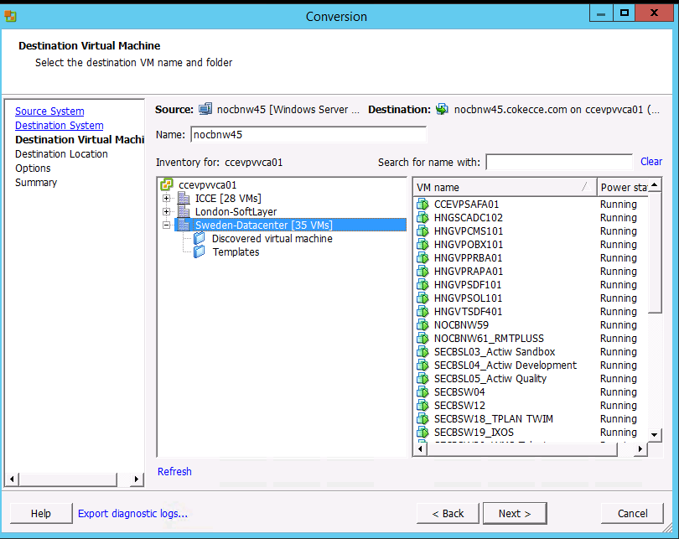

Select the datacenter and enter the name for vm shown as above

Select the Esxi host and data store with sufficient free space

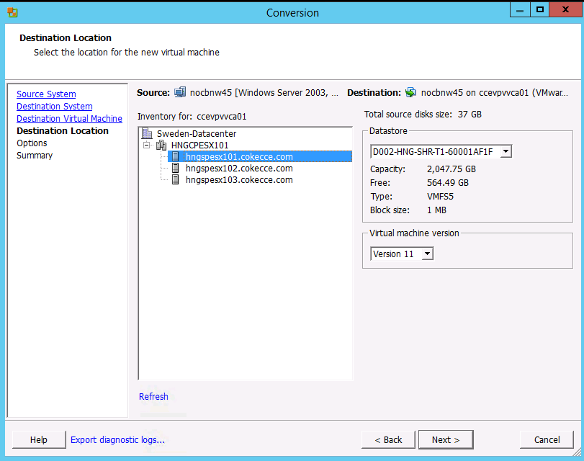

Click on Edit in advanced option

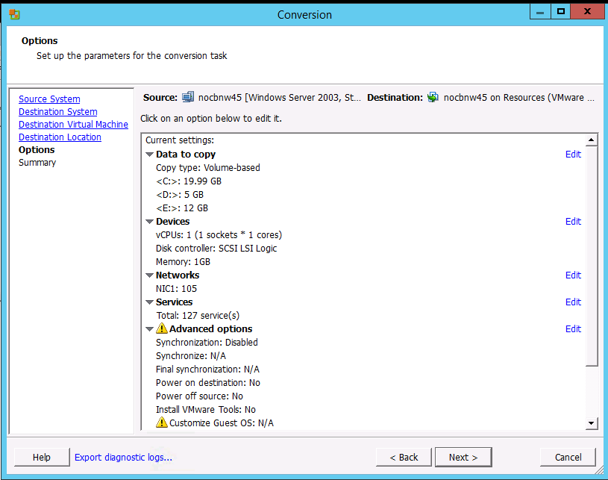

Enable synchronize changes

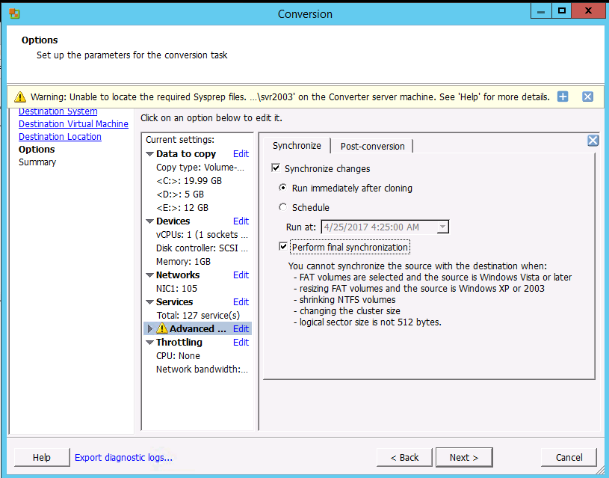

**Uncheck final synchronization as this will be enabled during the final sync**

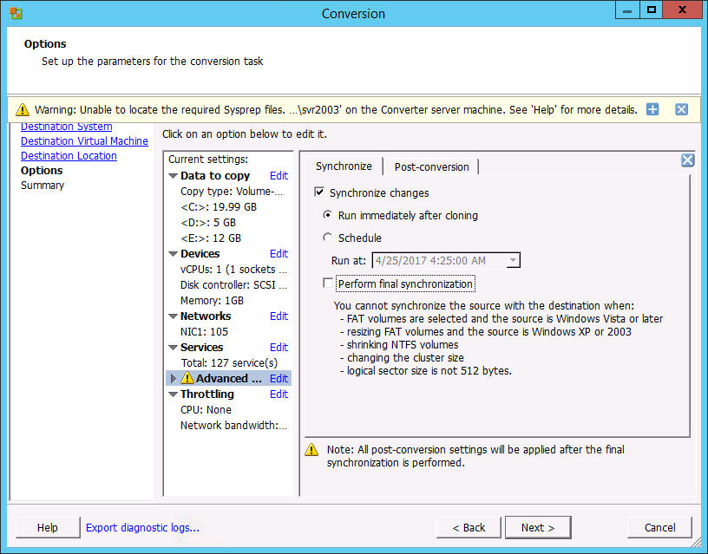

Click Next

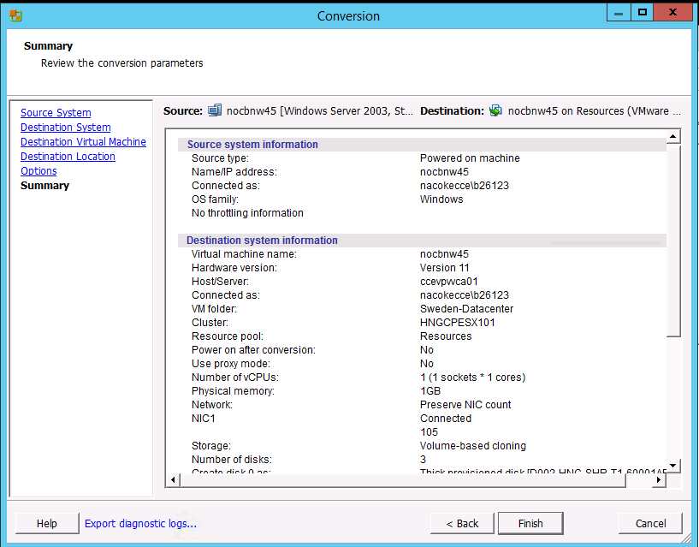

Click Finish

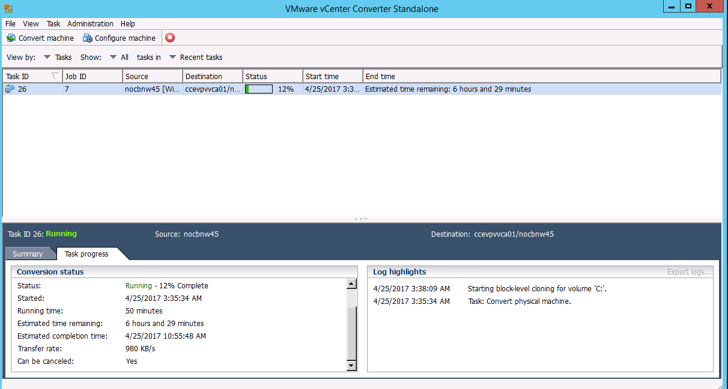

Job status

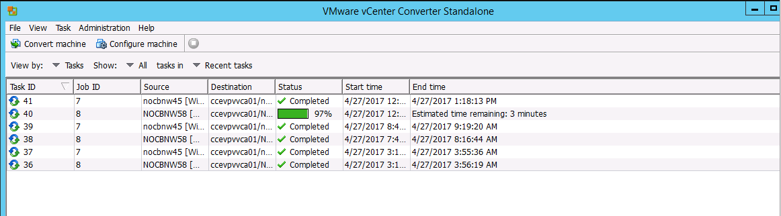

Do periodic sync until the final synchronization

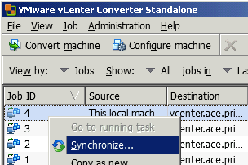

**FINAL SYNCHRONIZATION**

Select Advanced option 🡪Edit

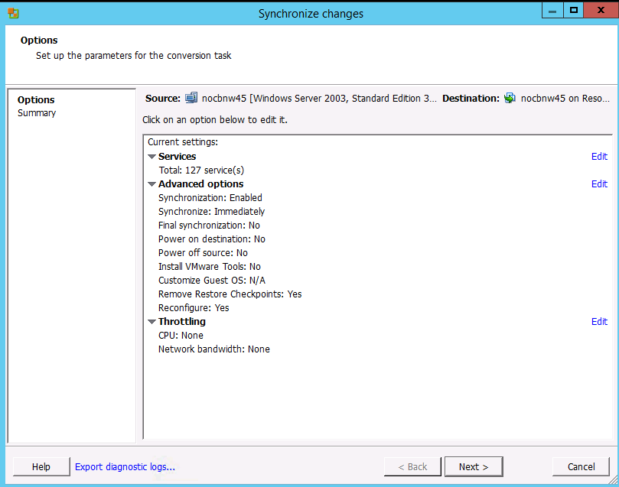

Enable the Perform final synchronization check box

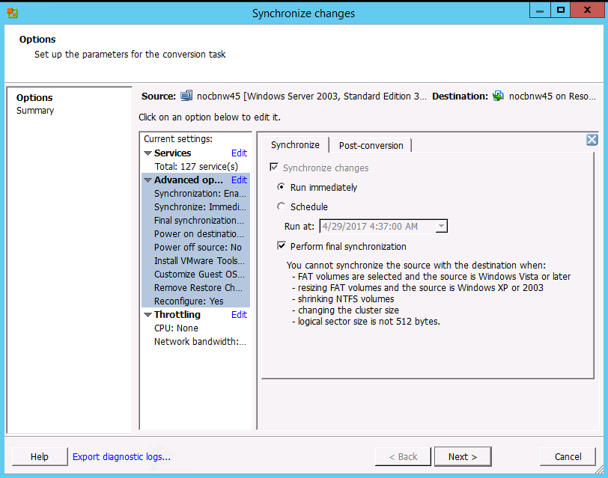

Select the post-conversion screen and click on the check box as shown below and click Next

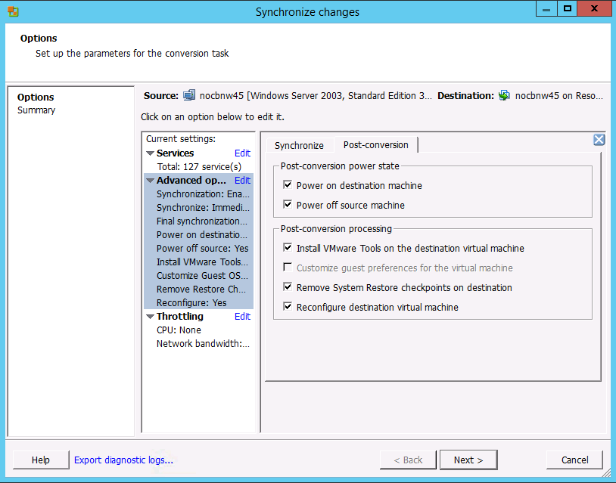

Click Finish

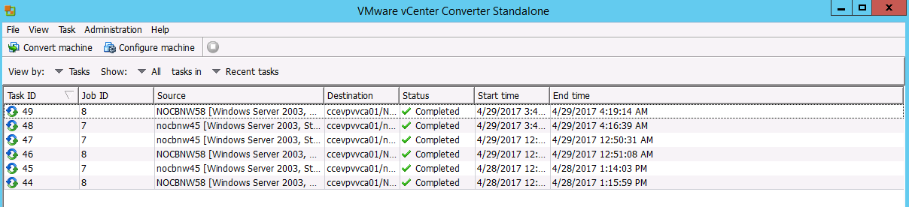

Completed job status